CSD 2550 – Web Applications and Databases

Humzah Javid - M00492618

Shabbir Mowlah – M00506802

Abdul Hassan – M00495457

We have decided to base our E-commerce website on watches as these timepieces play an important role such as making one more punctual, it can commemorate special occasions, and is also used to show how people express themselves for example putting on a nice watch is one of the perfect accessories after finishing off with a suite and tie. Smart watches allow you to use your phone without attracting attention and thus reducing the chances of being robbed. Some also enjoy collecting rare timepieces such as those from “Patek Phillipe, Jaeger LeCoultre Reverso, Kari Vouilainen and many more.

Below is a description of the website

**Header:**

Contains a **Title** for the current page, a mute button and shopping cart button below that is an animated **Navigation bar**, which displays the links for all the pages on the website

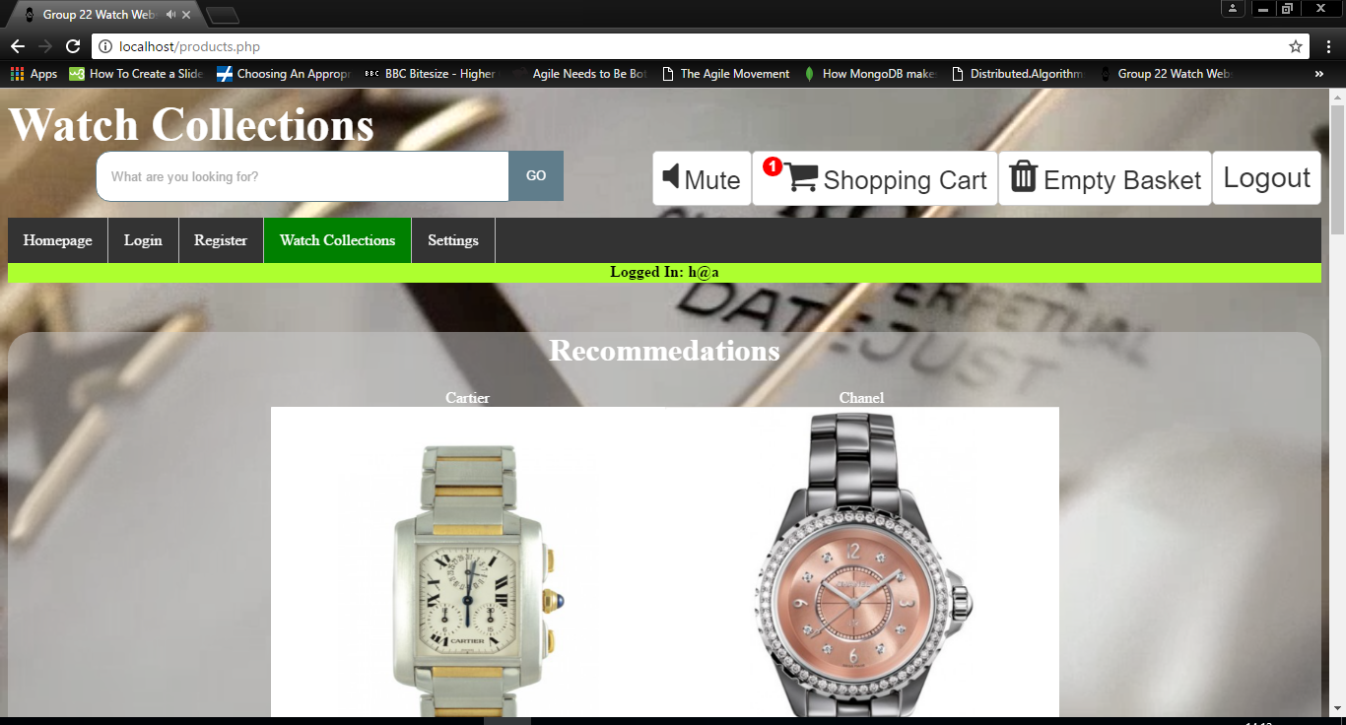

**Two banners header and footer:**

The header banner dynamically its changes colour and text depending on if a user is logged in or not. The footer banner contains a string "This website was created by Group 22 2017".

Footer



**Content:**

Contains the relevant content for the page will be placed. Is placed on a translucent text box.

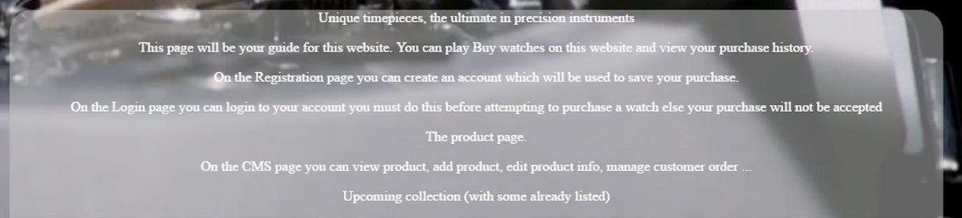

**Animated background:**

The background is a custom-made video/audio file made using Adobe Premiere Pro CS6. The video background hides the default video controls. However, the music can still be muted through the use of the mute button at the top of the page.



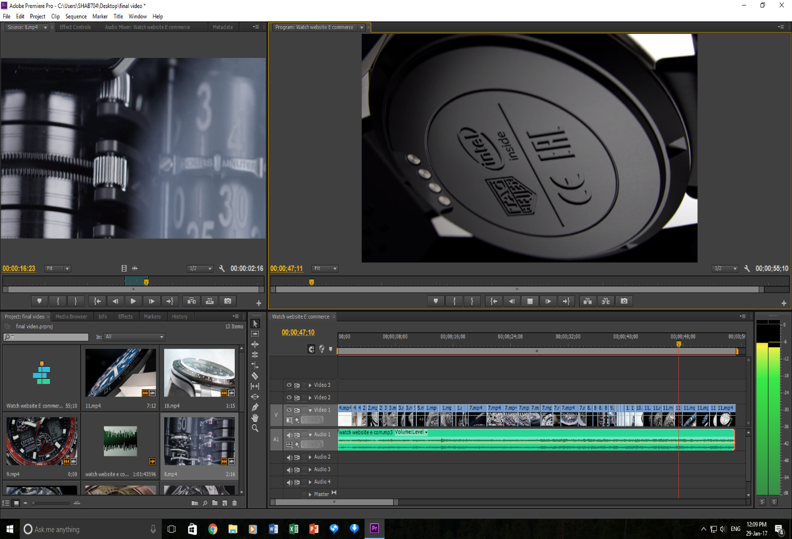

**Homepage:**  
The homepage will describe what content is on each page, and will help the user decide what pages they wish to go to.

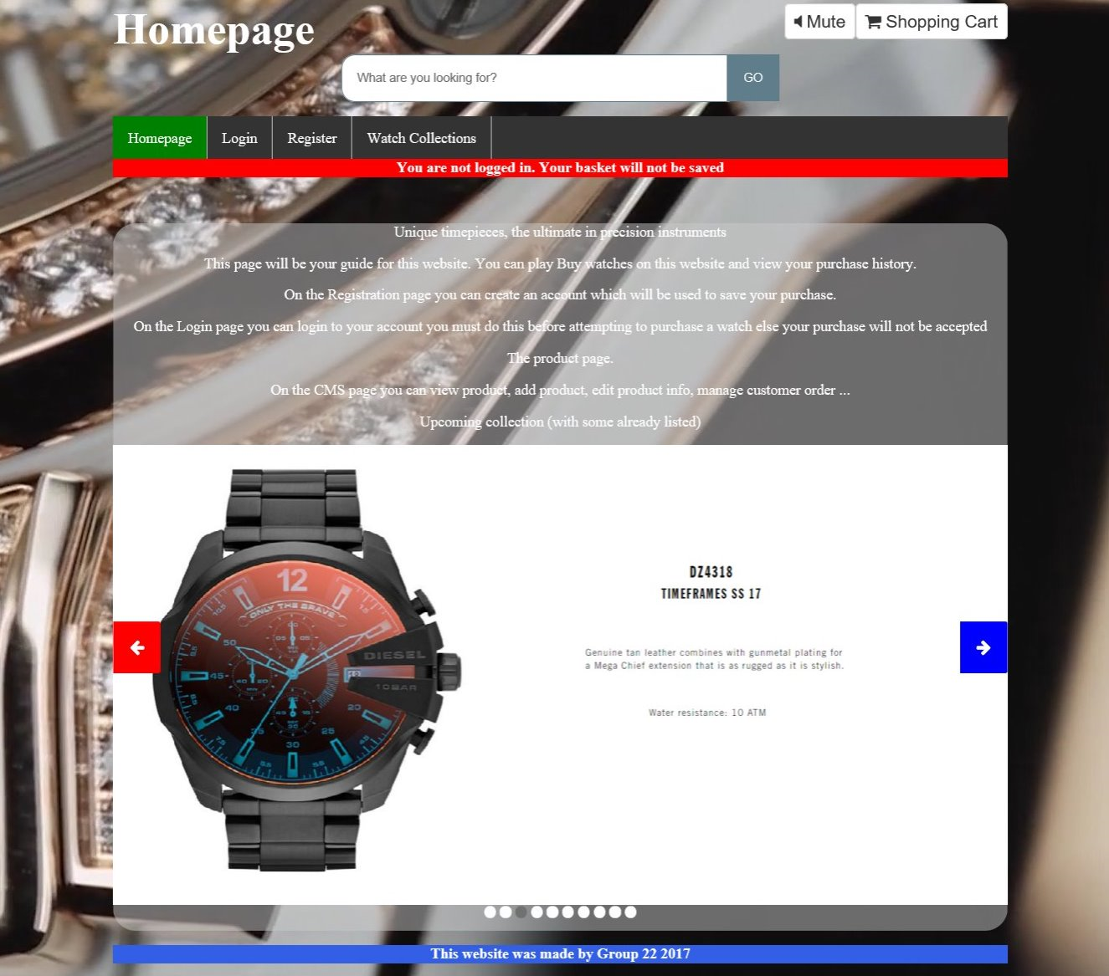

**Login:**   
The Login page will allow the user to login, but also links directly to the products page and to the registration page, should the user wish to bypass or postpone the login procedure.

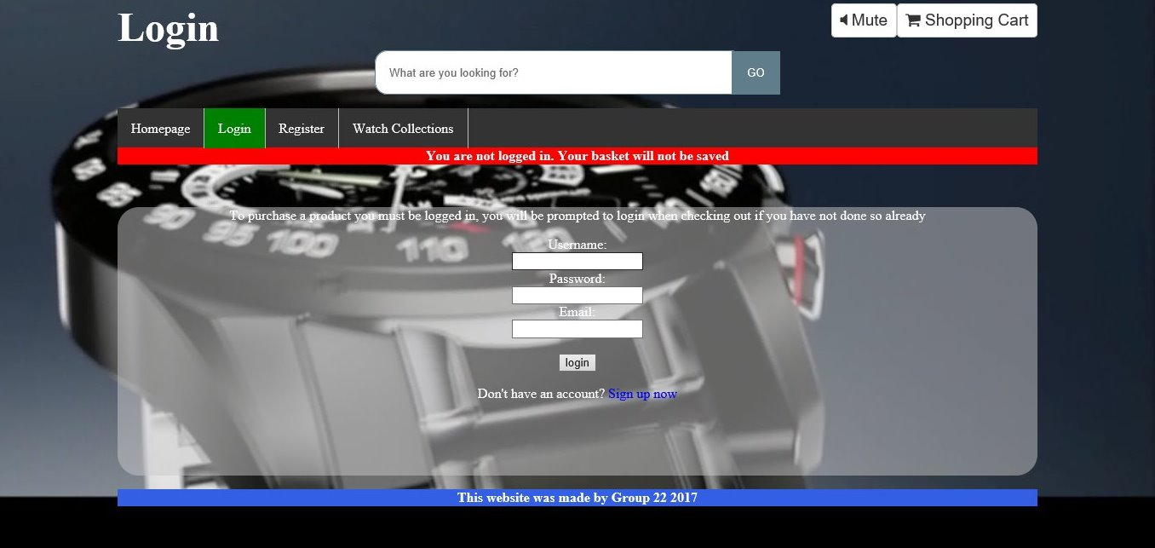

**Register:**

This page will allow the users to sign up for an account, but also links directly to the products page and to the login page, should the user wish to bypass the registration procedure.

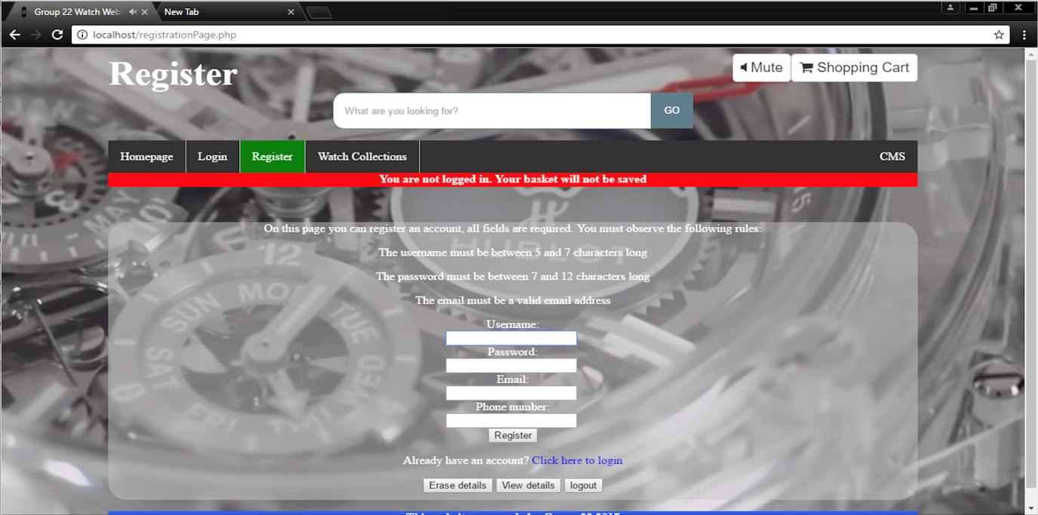

**Watch Collections:**  
This page allows the user to view the current range of watches we have for sale. Hovering over the image of a watch will replace the picture with a description. Users will be able to add items to their basket by clicking on the respective image.

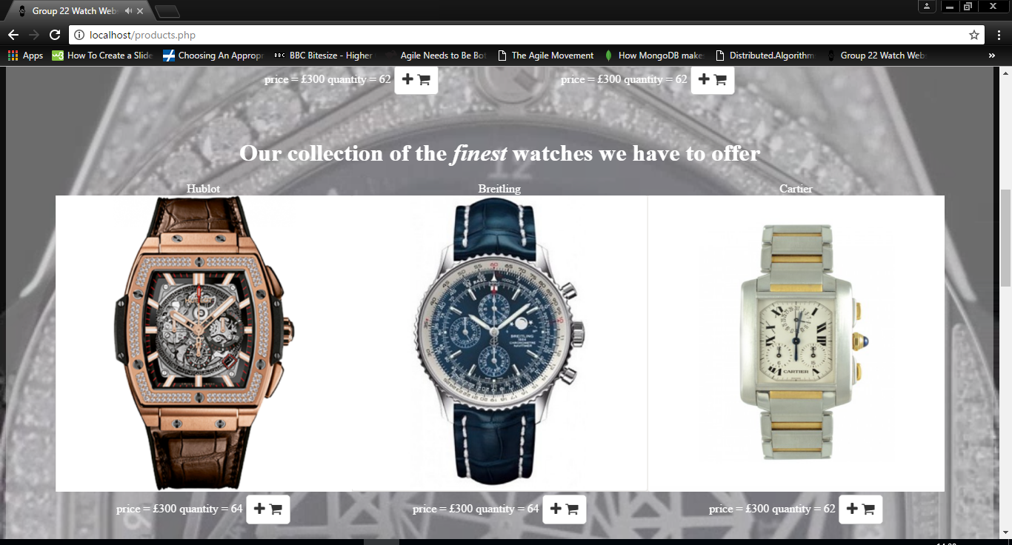

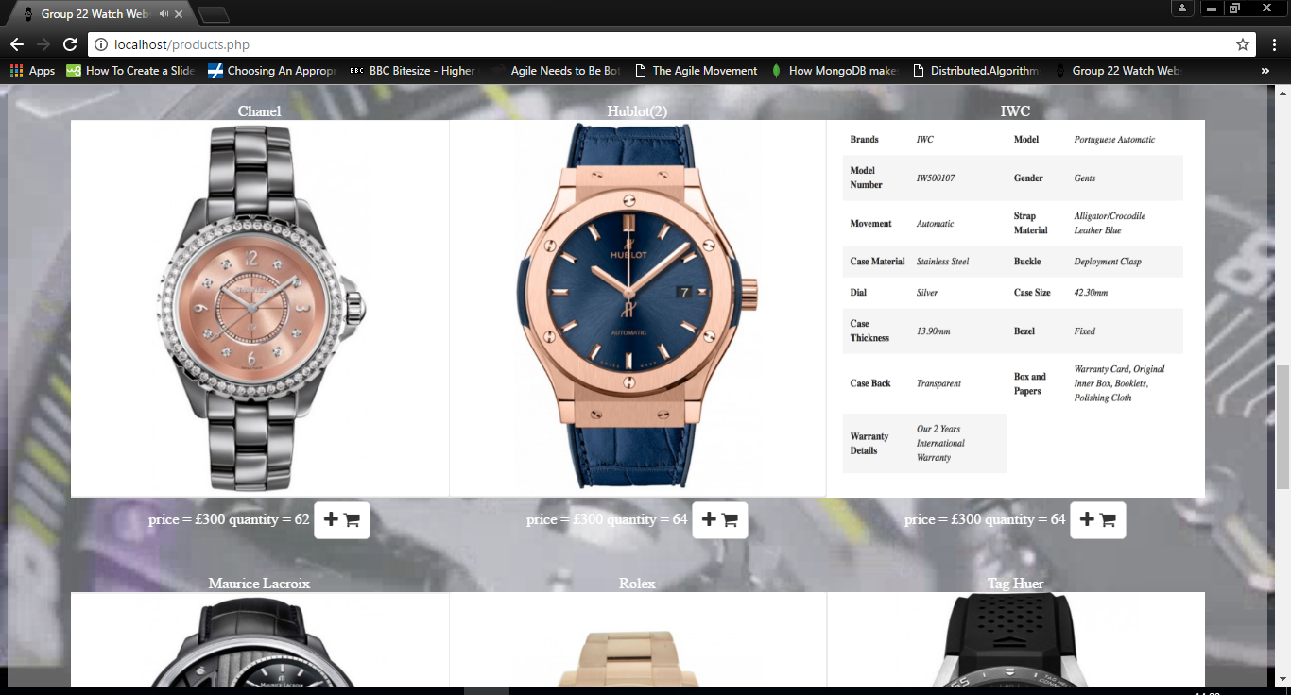

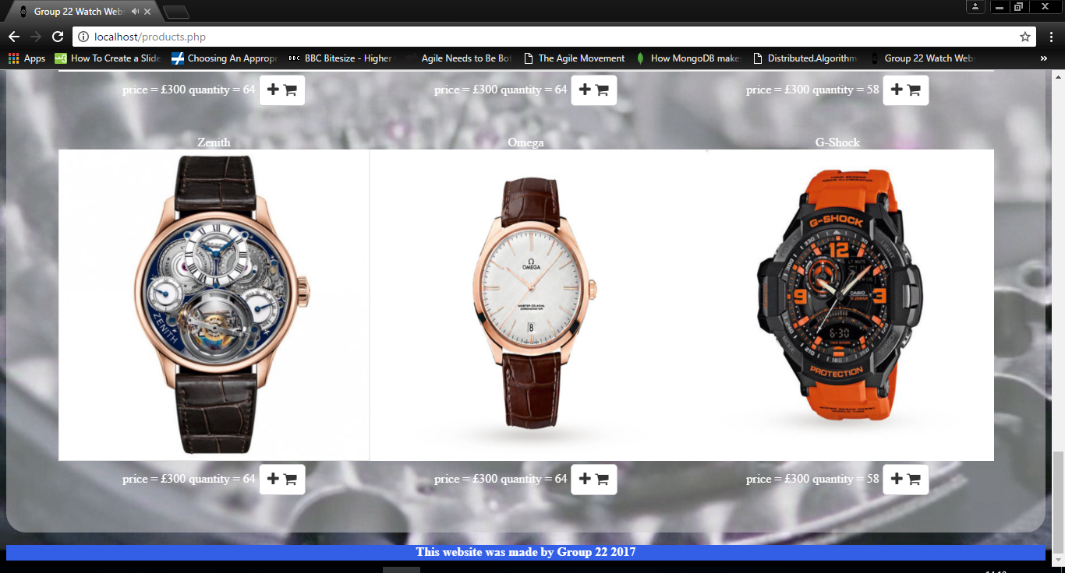

**Settings page:**

On this page are links to pages which allow the user to edit their own details, view their past orders. These additional server side pages are only accessible if the user is logged in

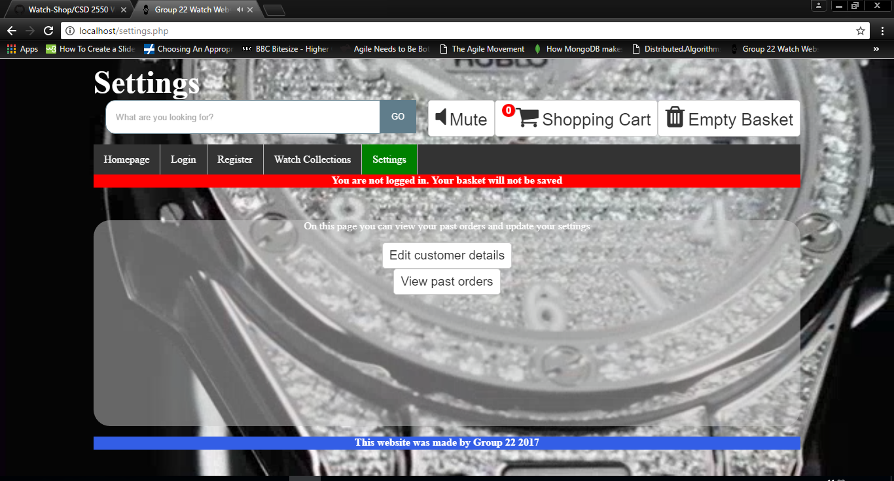

**Further information about Third party libraries:**

The only third party library used is Font Awesome (initially designed for Bootstrap, but can be used without it which is what we have done), to provide the icons seen on the mute and shopping cart buttons and search bar. In addition to the icons seen on the CMS page.

**MongoDB database Design and Description**.

**Database**

In the following images are the collections Admin, customer, product, orders, keywords,

**Admin**

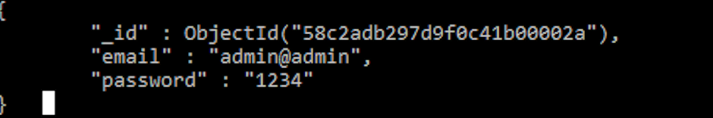

**Customer**

Our customer collection which includes the name of the customer, phone number, user name and email. Moreover, it important to have information about the customer as a result of login in and order product throughout the website.

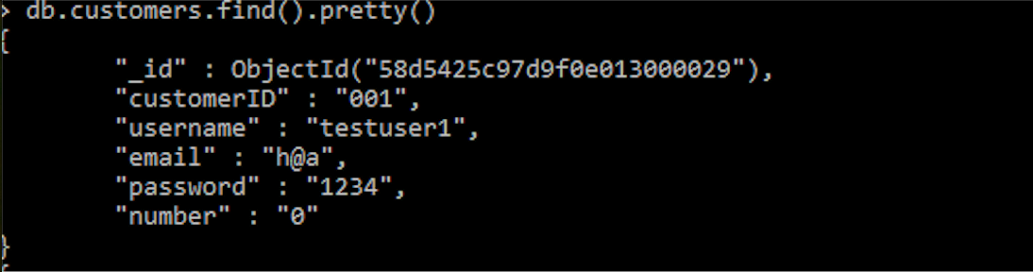

**Product**

Our products collection which includes name of the product, description and stock. Furthermore, product enable the customer to buy item in the website, according to our list the customer can look for product that are specific.

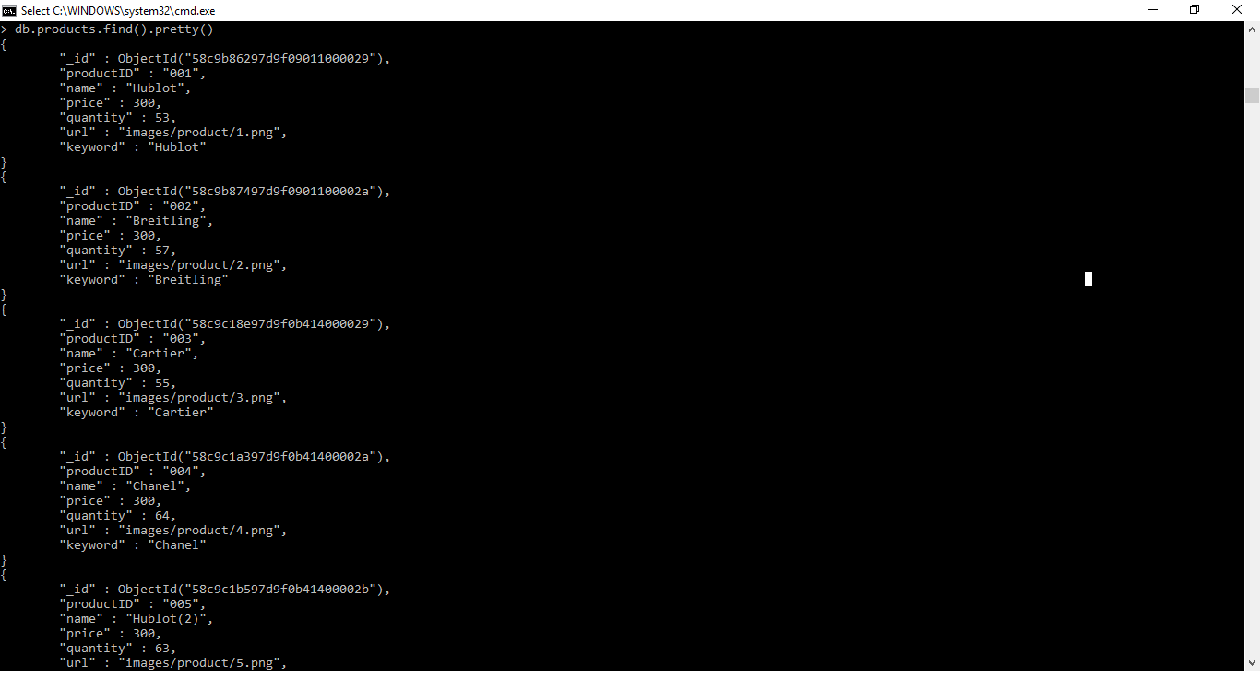

**Order**

Our order collection it includes the customer id, product id and quantities. The order is crucial in our website because it permit to give the proper product to the right client and the amount of product that the customer bought.

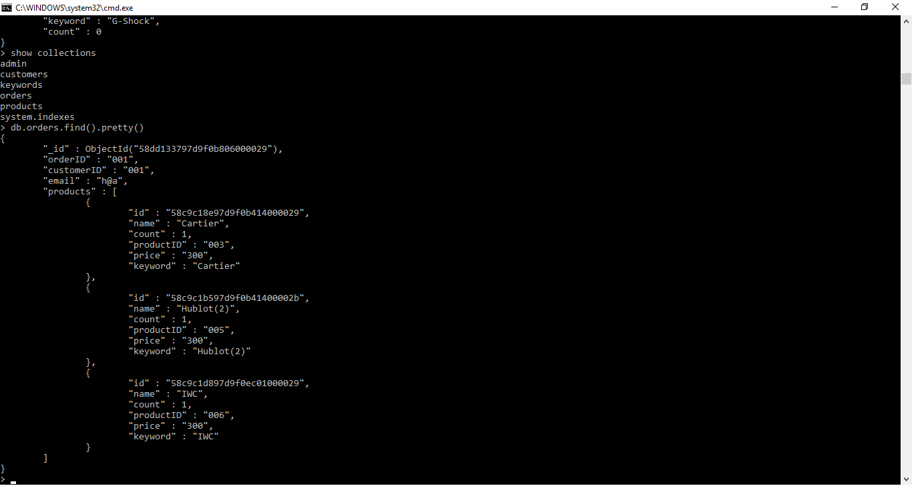

**Keywords**

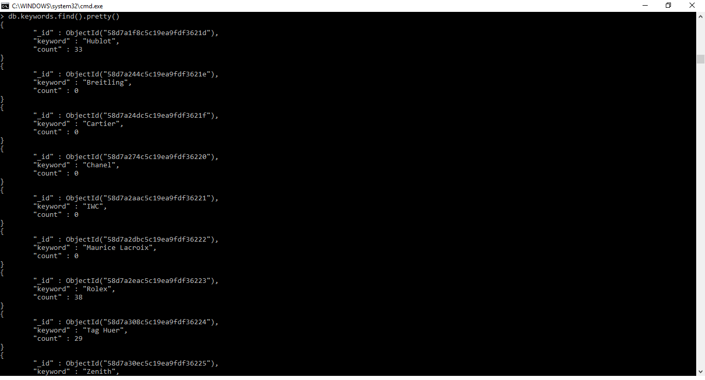

**Other improvements added to the website**

**Basket**

Customers can add products to the basket with the basket showing an indicator for the number of items in the basket. After clicking on the basket, the order is placed in the database, and displays an order summary, they can also clear the basket.

**Redirecting user**

Certain pages/features of the website cannot be accessed until certain conditions have been met. To prevent these pages/features being accessed the user is greeted with a message and is redirecting to another page. An example of this is when a user tries to view past orders or view/edit their details. If they are not logged in the user is redirected to the login page.

**Auto generated IDs**

The mongoID is difficult to use in the CMS so each customer, order and product is assigned an ID numbered from 001 to 999. This is done via Two functions in the common.php file

**Searching for products**

Customers can search for products by keywords. The results can be sorted by different criteria e.g.(price, quantity, alphabetically).

**Customer tracking and recommendations**

Customers who are logged in get recommendations based on their past orders, they can view their past orders and can update their details, and regarding those who are not logged in they only get recommendations for the most popular products.

**CMS**

This is used for the staff

Customer management system

Staff can log in and add products

View add and delete products in addition to viewing and deleting customer orders

CMS Figure

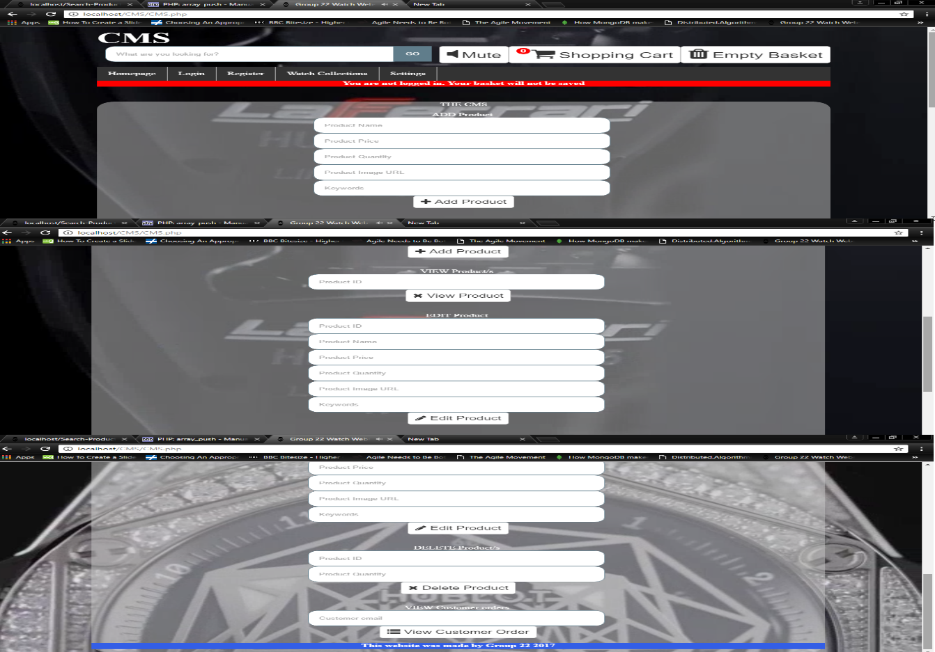

**AJAX**

This is the communication from the server to the customer which is used for the login, registration and recommendations.

Example in the figure below which shows the result of ajax communication between client and server

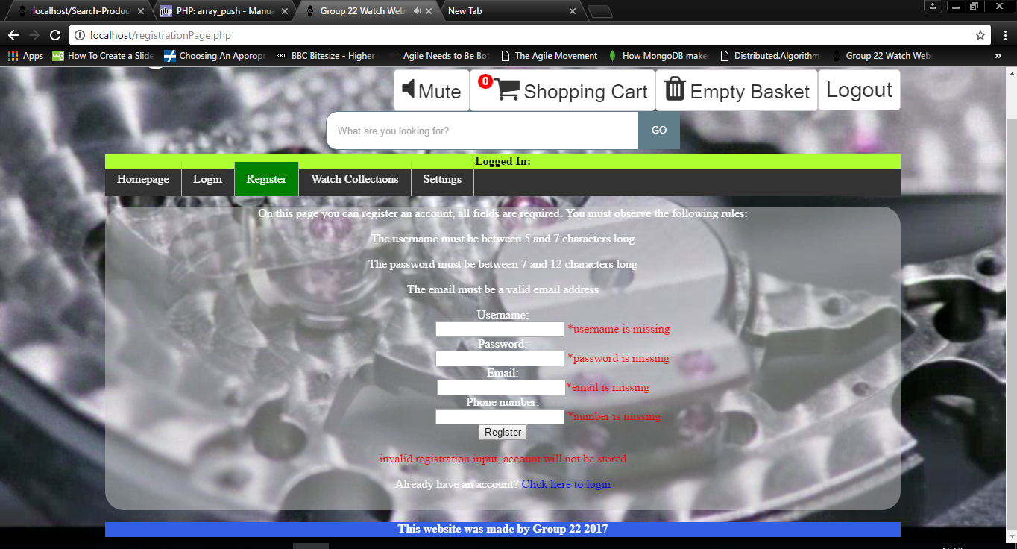

**Security, Privacy and legal issues.**

For the security and privacy of our customers we do not require a customer to alternatively log in with their Facebook or Gmail account we eliminate the risk of external hackers knowing personal information such as gender, address, driver’s license details, political views, personal pictures and many more. We also ask for only the required information such as an email address and to create a user Id and password for a more straightforward convenient registration.

Problems we encountered were that our website was prone to NoSQl (Mongo DB) injection attacks. This would happen when the search query would contain data interpreted as a command to run and these commands could have been inserted by a malicious user to drop our tables (Reference: “little bobby tables”). So, to overcome this security issue when our server accepts an input from a user we have sanitised the input string which removes any tags.

Our solution (“$password = filter_input(INPUT_POST, 'password', FILTER_SANITIZE_STRING);”)

(“$email= filter_input(INPUT_POST, 'email', FILTER_SANITIZE_STRING);”)

To also enhance the security our server has a firewall which serves as an extra layer of protection this ensures that external attackers have restricted access, this limits the information that are vulnerable to exploitation.

The problem we have is we are not using “mongo db. server. Authentication” but in the future if we were to do so we would eliminate the risk of an attacker eavesdropping so that communication between client and server isn’t sent as a plain text over the network. Also avoid the risk of having a malicious replicated server that would steal personal information such as credit card details and various other information’s.

Authentication is the process of verifying the identity of a client, by using this server, mongo dB would require all clients to authenticate themselves in order to determine their access.

With regards to the legal issues our background video was created with after effects and premier pro, and our images for the products page were taken but modified to suite our website so therefore it is not as the original.

When using php functions to erase session variables the cookie doesn’t fully erase itself as it can be located via the browser developer tool, this then leaves a footprint/trace of the cookie, this can potentially be used to hijack a session.

**Testing:**

**HTML/CSS Validation**

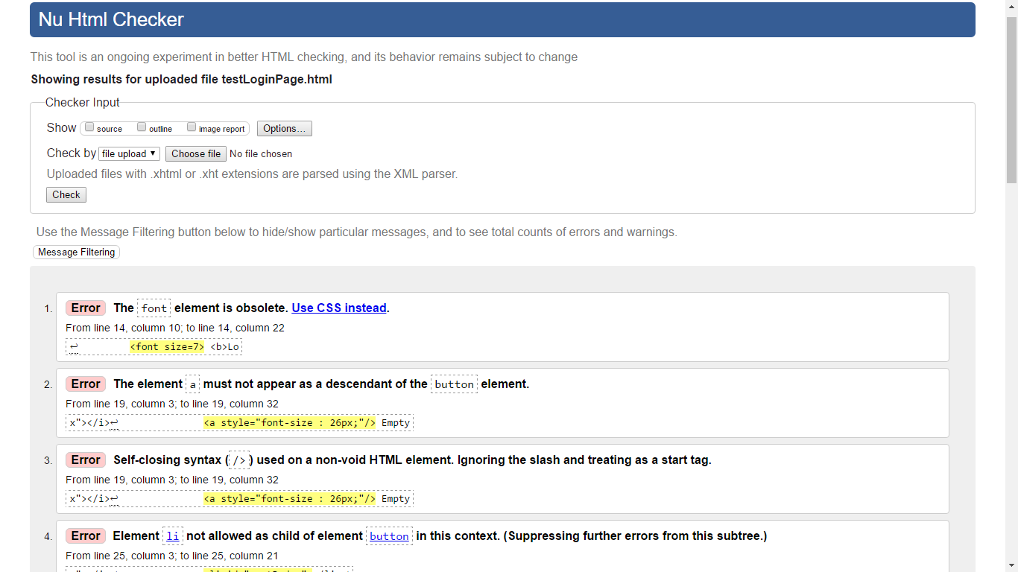

This is the HTML/CSS validation for login Page ¼



This is the HTML/CSS validation for login Page 2/4

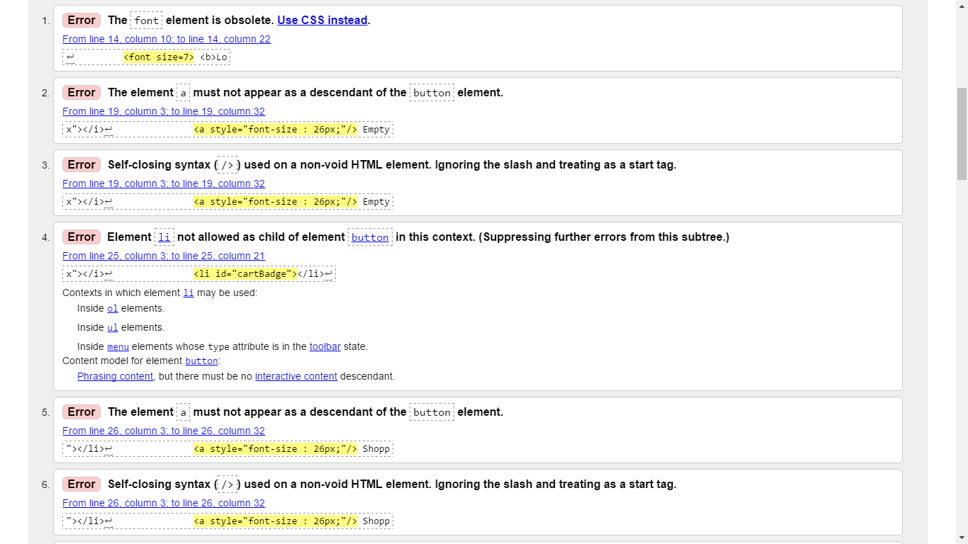

This is the HTML/CSS validation for login Page ¾

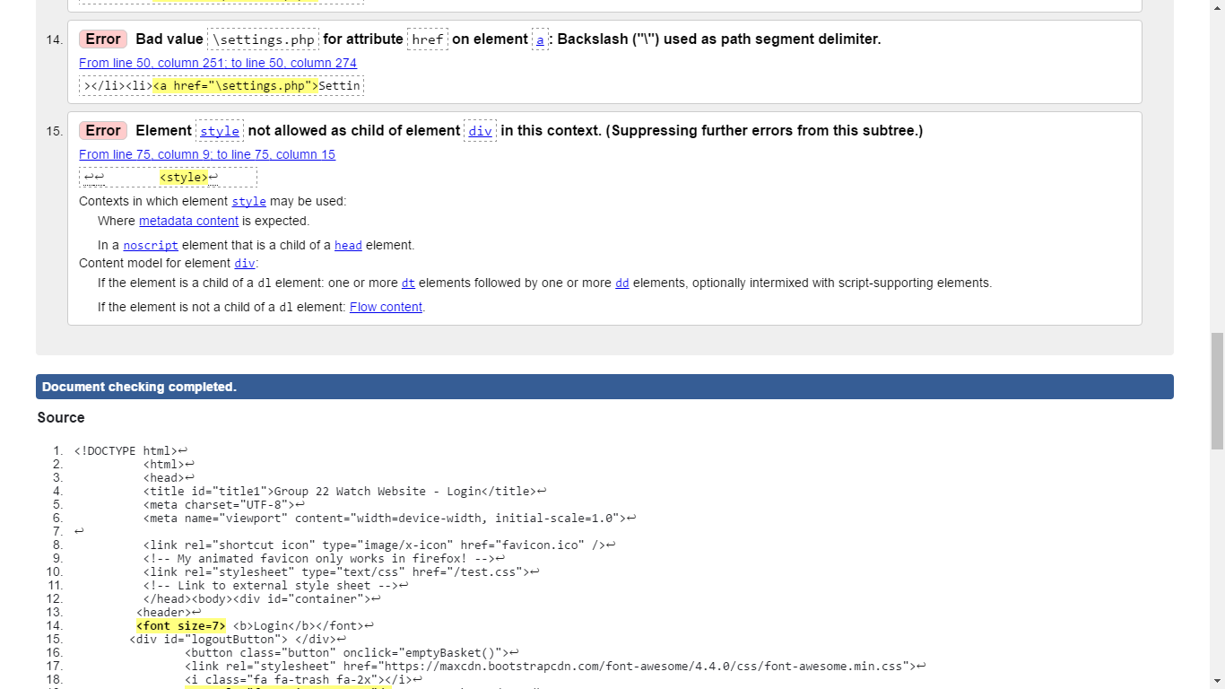

This is the HTML/CSS validation for login Page 4/4

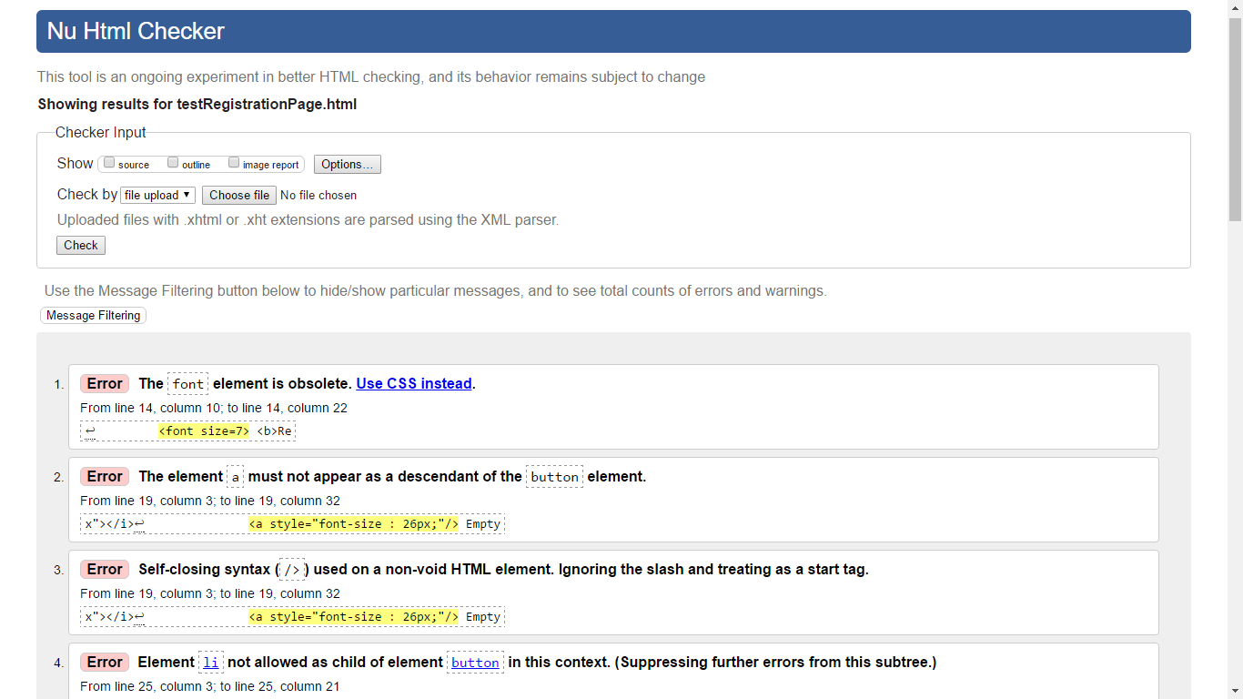

This is the HTML/CSS validation for registration Page ¼

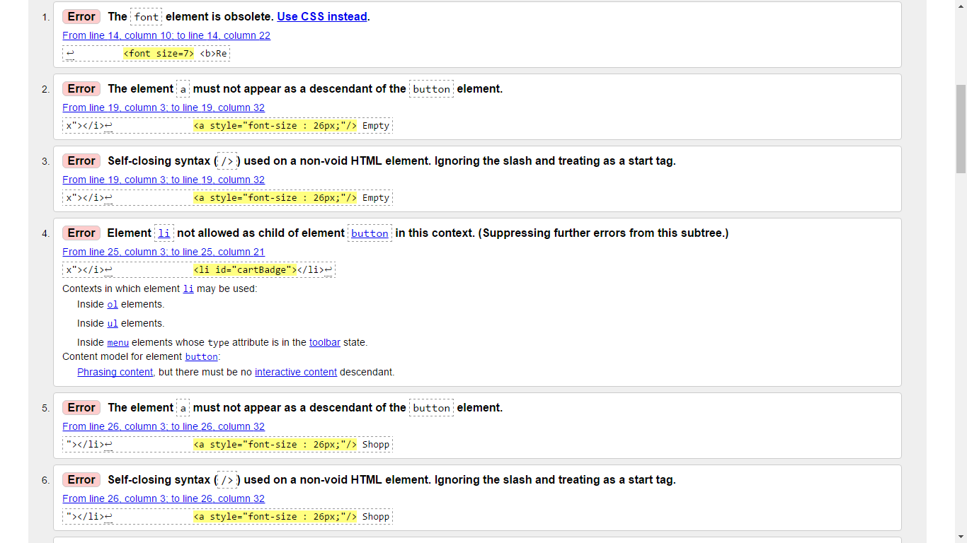

This is the HTML/CSS validation for registration Page 2/4

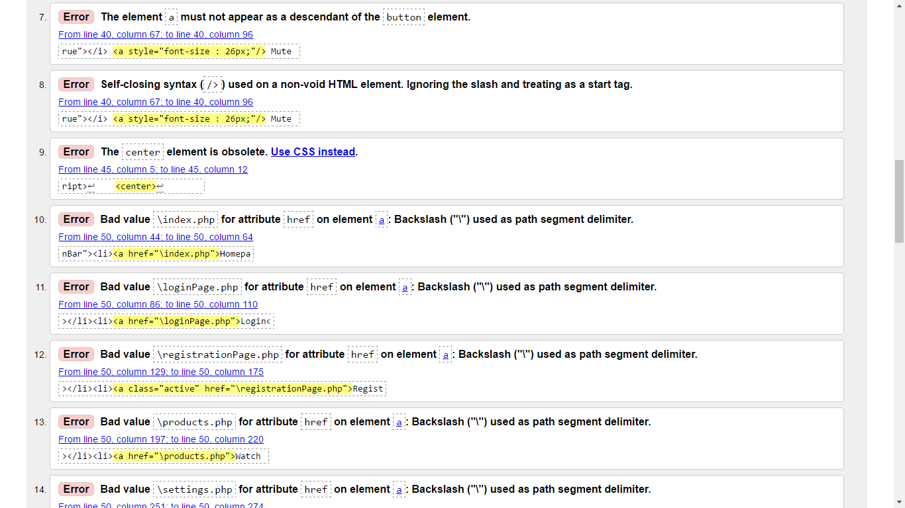

This is the HTML/CSS validation for registration Page 3/4

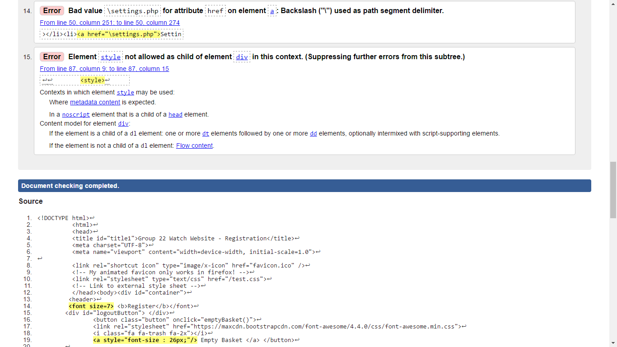

This is the HTML/CSS validation for registration Page 4/4

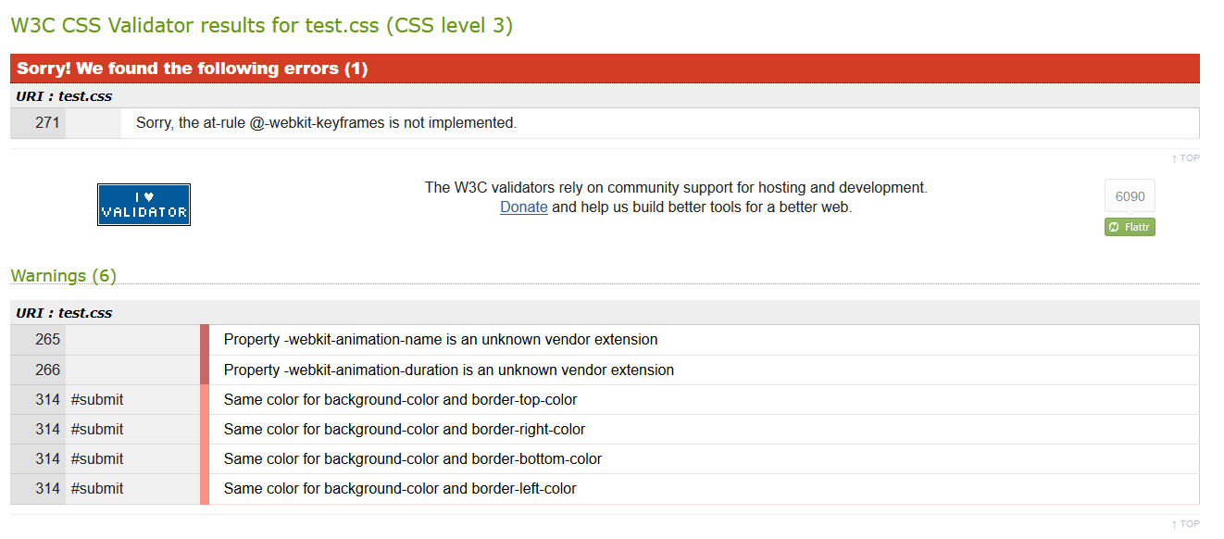

Validation for CSS

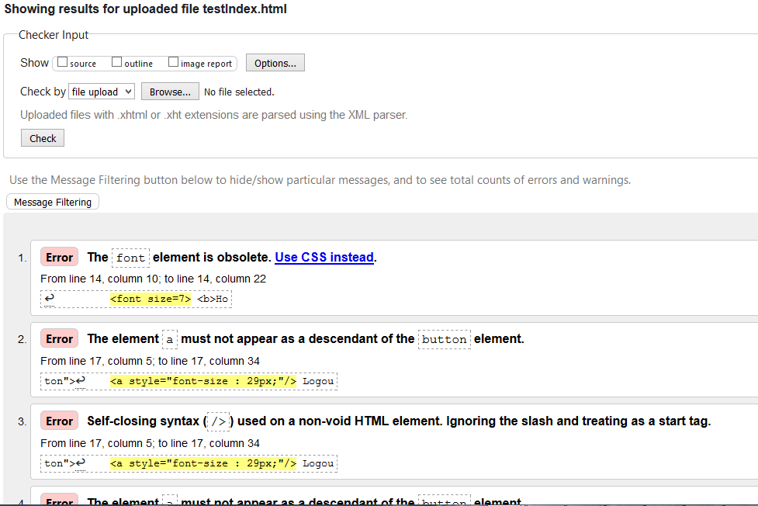

validation of the homepage

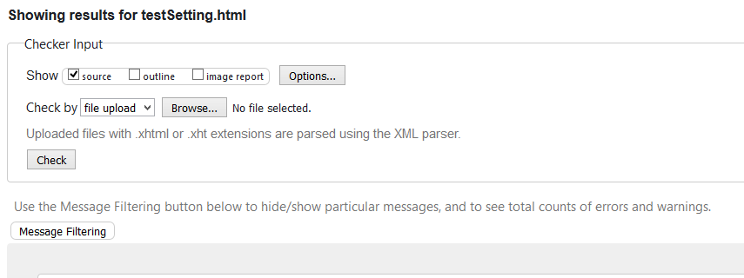

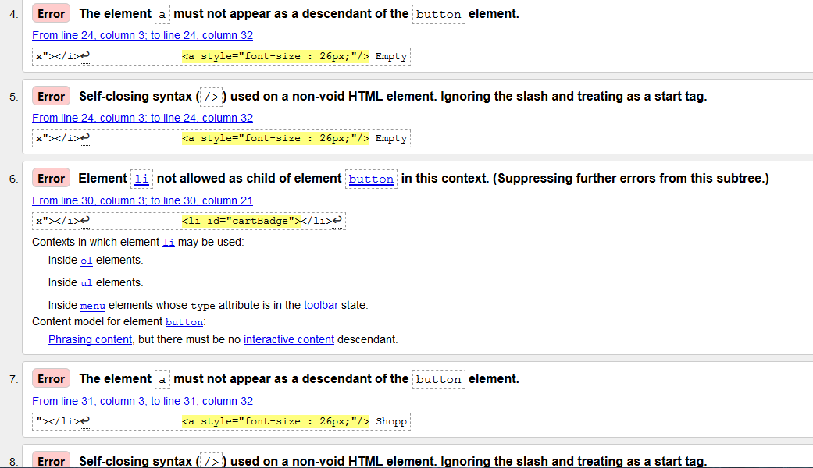

validation for the settings

**Front end testing**

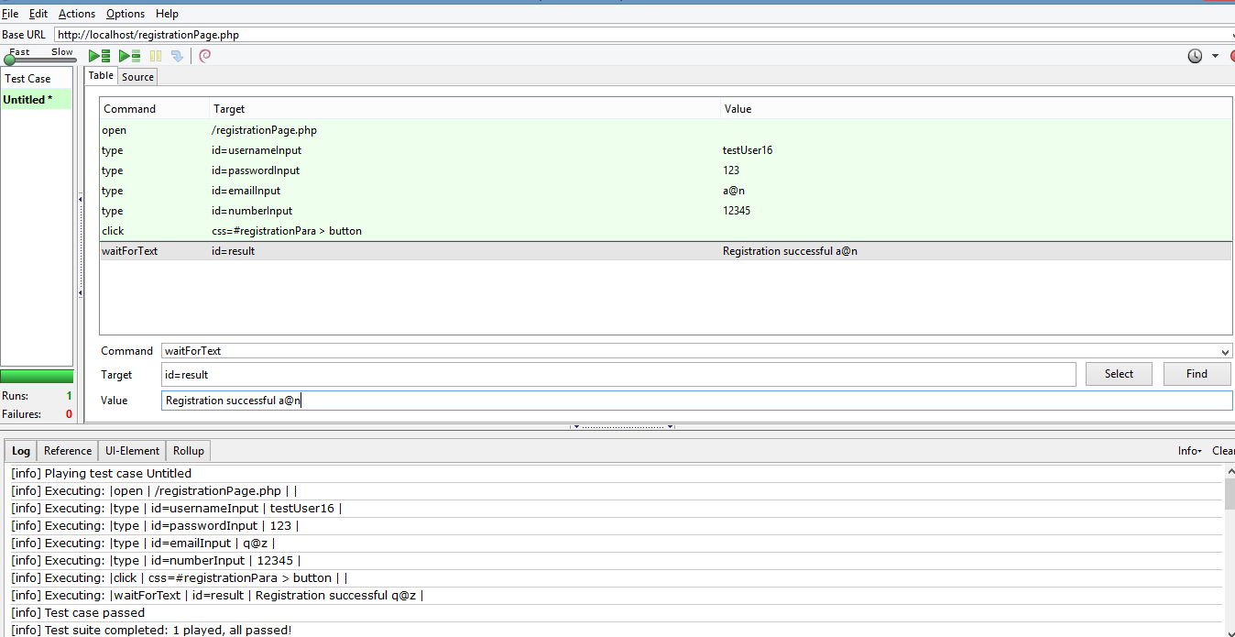

Front end register selenium ide

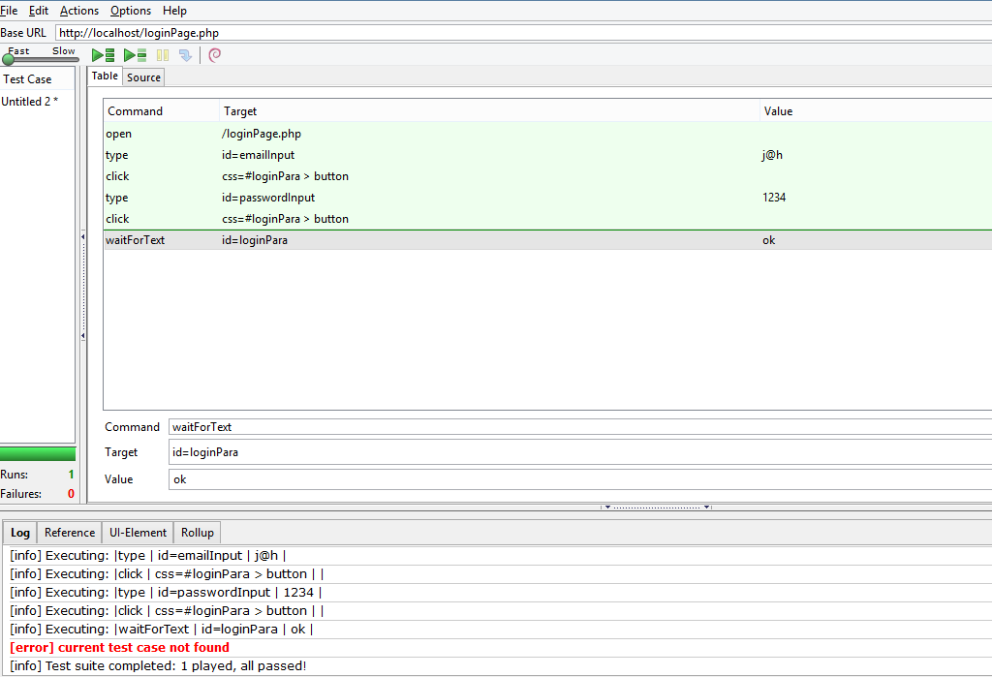

Front end login selenium ide

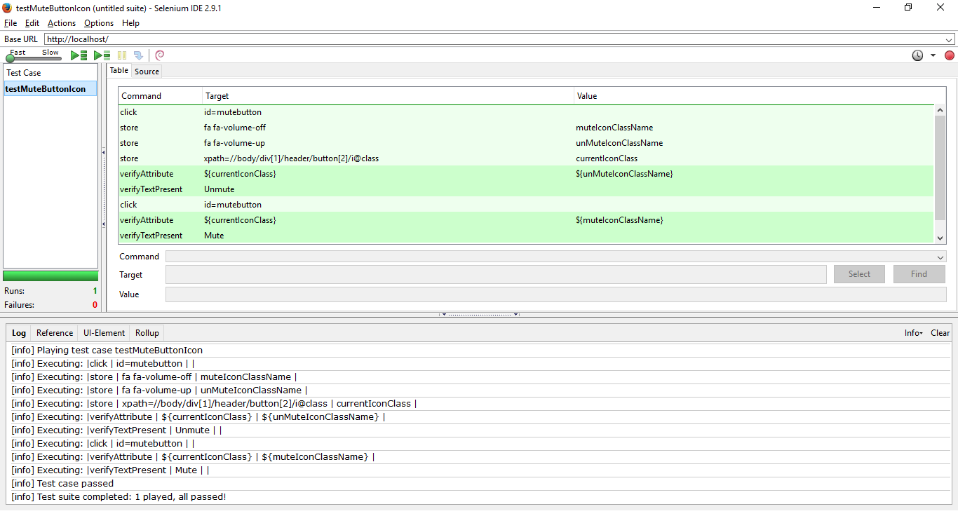

This is the test for mute button icon,

Testing whether the mute button icon (initially clicked once to set it to mute) changes its icon and text from unmute to mute, this is done by checking its class name and text

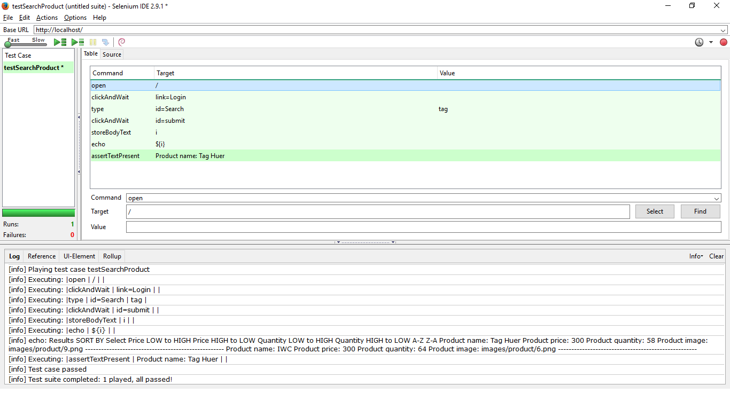

This is the test for the searching of products,

This test enters an incomplete keyword 'tag' in the product search bar. Tests if the result contains the correct product 'Tag Huer'

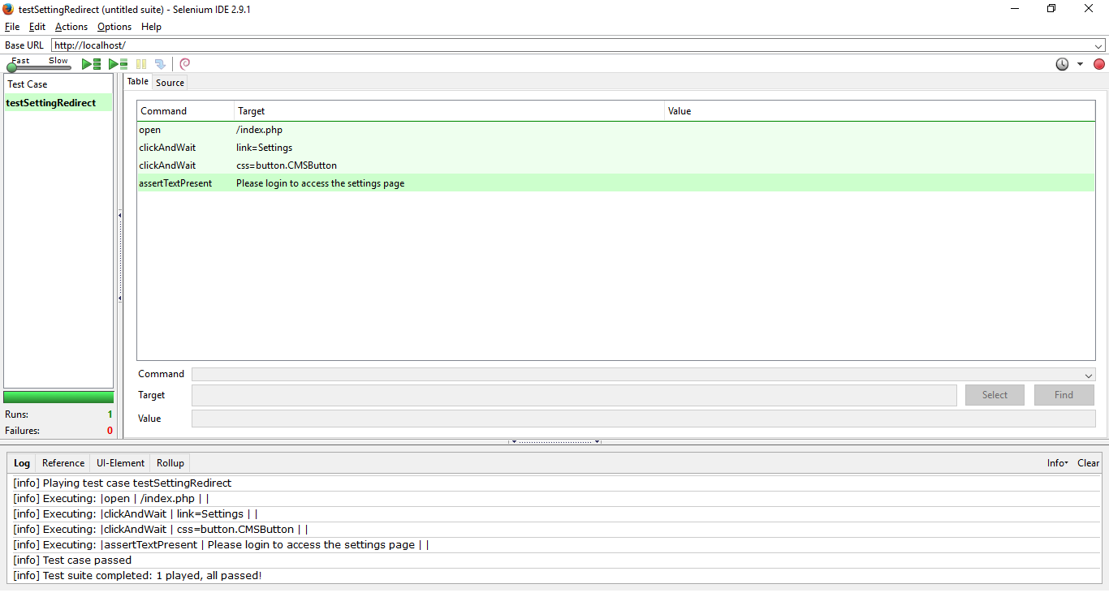

This is the test for redirecting users from the settings page buttons.

This test attempts to access a button on the settings page whilst not logged in, and tests if the user is greeted with a redirect message upon attempted access.

**JavaScript unit testing**

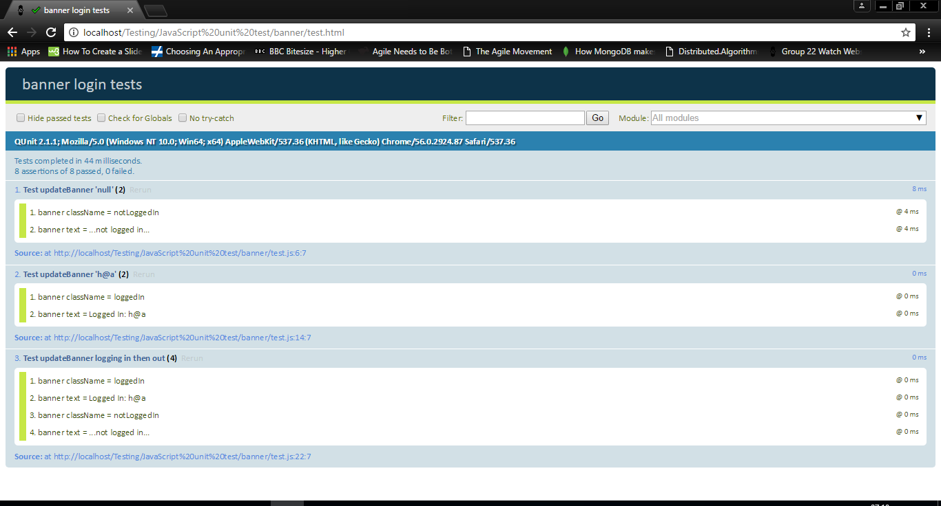

Banner unit test

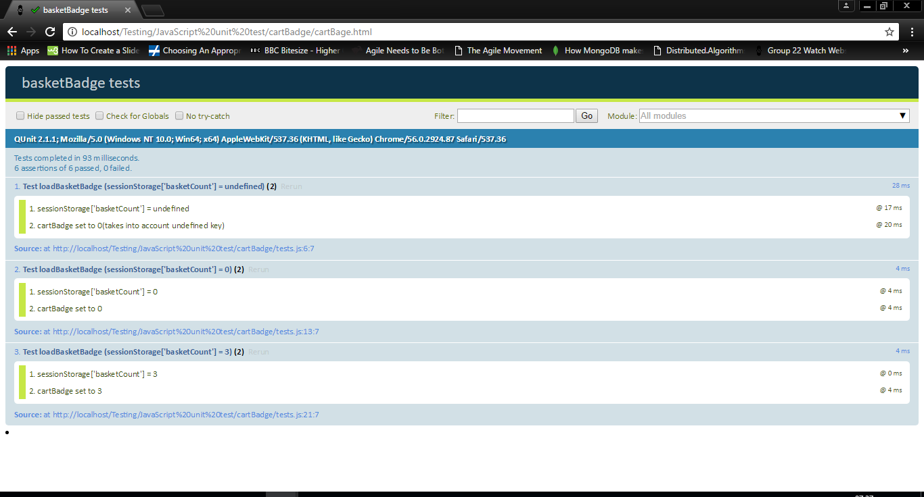

Basket Badge unit test

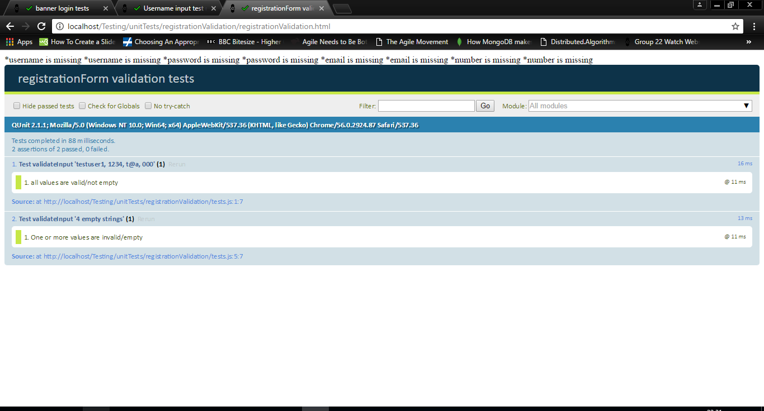

Registration Form Unit test

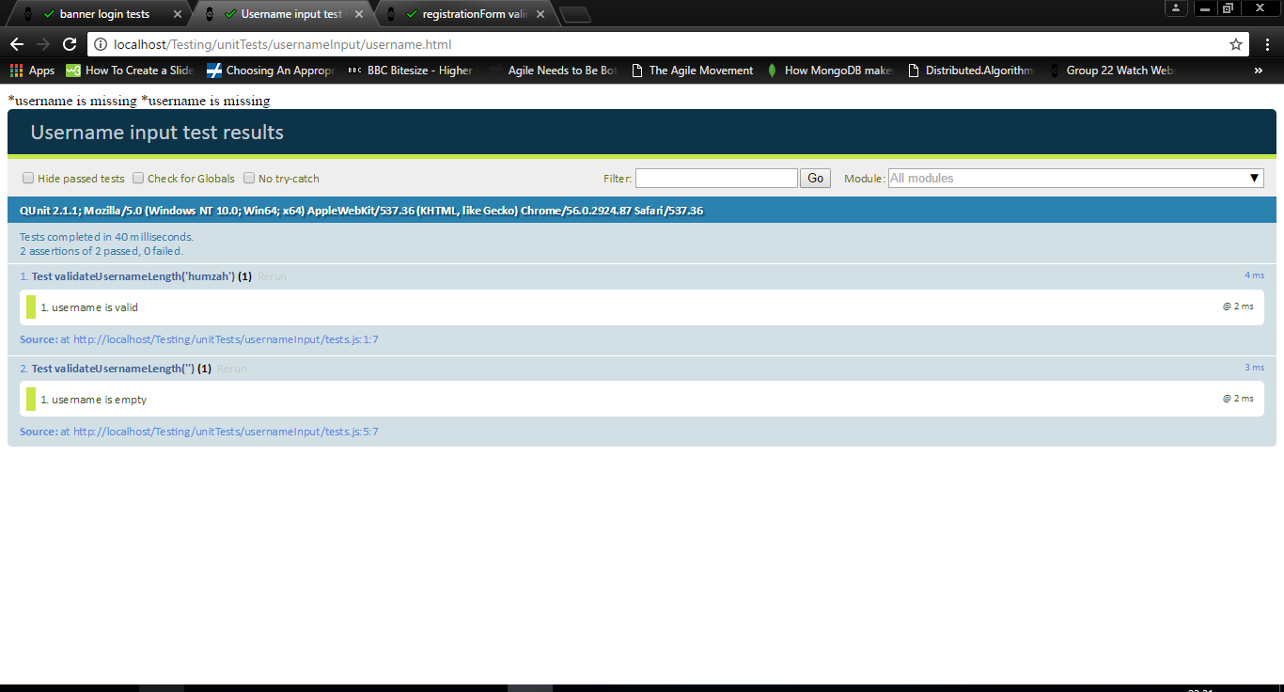

User name input unit test

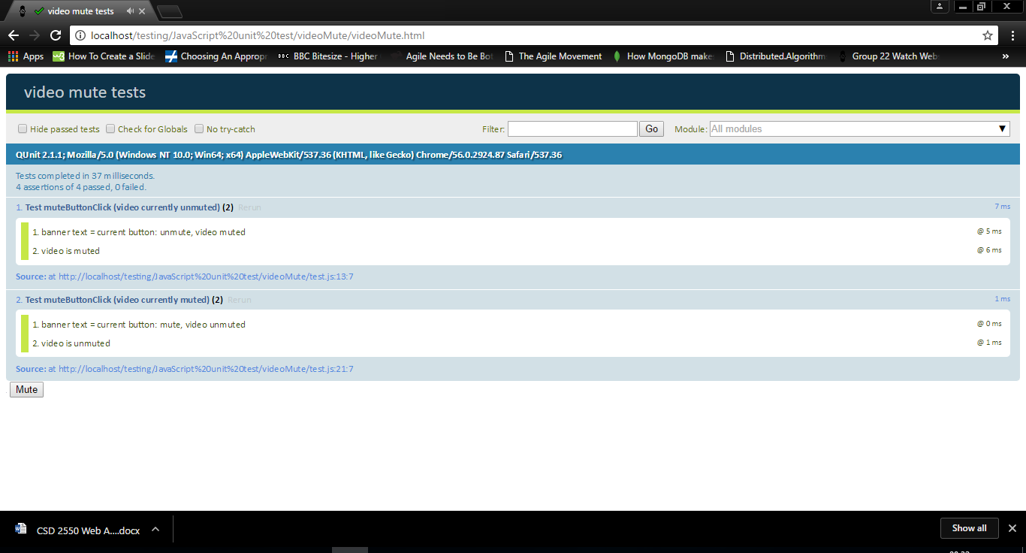

videoMute unit test

**PHP unit testing**